-16K
Portable Outdoor Battery LED Floodlight
Outdoor Sports

Designed for instant, temporary floodlighting anywhere, FLOOD30-16K is an extremely high-brightness, battery powered LED floodlight, fully designed for outdoors in a compact & rugged case. It’s ideal for quickly lighting training grounds and requires no planning permission in most areas. The unit can also be powered &/or charged from mains. Now with a massive 16,000 lumen output and approved by the English RFU for training.

The head folds flat with lens protected and neatly stowed; it can be removed for mounting on multiple accessories including 3.5m tripod stand. Designed and manufactured in the UK.
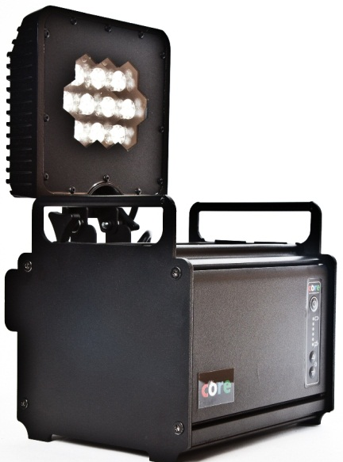

Key Benefits
- Enables weekday evening training from early Autumn through to late Spring
- Overcomes planning requirements in most areas (for mains powered lighting)
- Electricity consumption 1/7th traditional halogen area lighting
- Flexible – attach head to its portable 3.5m (12ft) tripod for light anywhere
  - OR attach to fence, scaffolding pole, roof etc.
- Ultra-high brightness: 4-6 units lights one third pitch for training 45m x 30m
- No trailing mains connection wires for a safer environment
- Two lithium battery types available for lower cost or longer lifespan
- 2 ½ hrs or 5hrs life at max brightness up to 50 hours by adjusting brightness
- Many other uses (eg public event safety, fundraising events, parties).

Compact size with
tilting/closing head
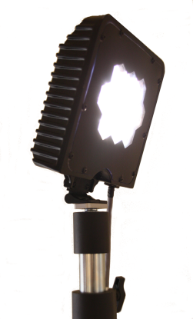

Portability & Simplicity

Simply plug in to charge, unplug once finished (up to 5 hours) then switch on. Or trickle charge from vehicle charger accessory (option). Retains charge for months.

Raise height up to 3.5m (12ft) on tripod system. Extender cable system allows connection to other fixings or permanent structures.

Selector switch to control intensity.

Removable Head. Attach to tripod or accessory

Multiple Uses from a single unit

Instantly lighting training areas

Public access safety (firework displays etc)

Area lighting for parties/functions

Power failure safety lighting continues on power dropout with optional mains supply

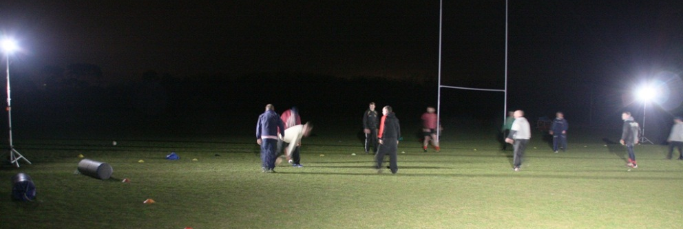

4-6 units to light 45 x 30m training area (1/3rd pitch)
“The CORE Flood30 lights now enable us to train on week nights Autumn through Spring …. 4 lights creates a training area some distance from the clubhouse. There was little chance of getting planning permission for installed lighting. CORE’s support has been excellent and the lights really do their job.” [Mildenhall & Red Lodge RUFC]

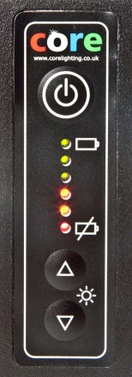
Light Head
- White LED Head using highest quality Cree high-brightness LED chips, Neutral White 4000K CCT
- LED output to over 16,000 lumens providing an intense brightness at 100W consumption
- Simple up/down intensity selector & LED display showing light intensity or battery level meter
- 3.5m very sturdy tripod in moderate wind conditions with in-built extension cable to the head
- Head tilts vertically from closed to 180° vertical for uplighting
- Standard 60° LED wide beam. Others available such as 30° (medium) or 22° (narrow).
- Convection cooled – no fan minimising noise & maintenance.
- Significant thermal heatsink design provides LED Lifespan >50,000 hours

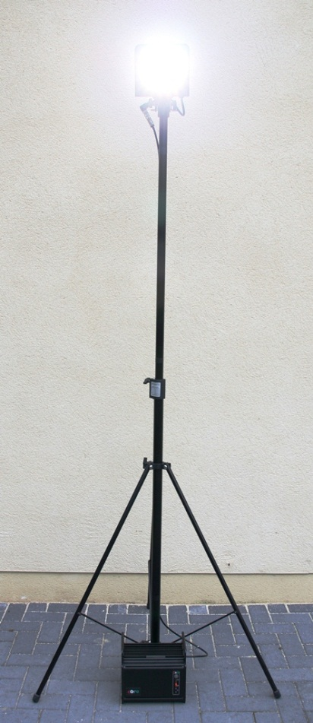
Power Source
- Operate from battery power at 100% or mains 80-240V/50-60Hz at 80% output
- Continuous battery operation on dropout of mains supply for backup lighting
- Full charge time only 4-8 hours depending on battery. Two options:
- 26Ah lithium ion for lower cost; 8Kg; 2 ½hrs @ 100% power ; >20hrs@10%
- 54Ah Lithium Ion for light weight, long life; 9Kg; 5 hrs @ 100%; >40hrs@10%
- Operating temperature -20 to +50 deg C.

Mechanical & Accessories
- Extremely rugged aluminium housing and head - powder coated
- 3.5m zinc plated steel tripod for ruggedness
- Optional wall plate for mounting head onto fences etc
- Attach lock and/or chain through handles for security (not supplied).
- Weight according to battery (see above). Dims 250w x 255d x 230h
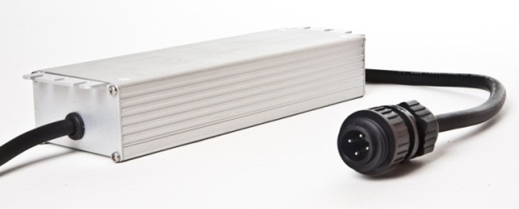
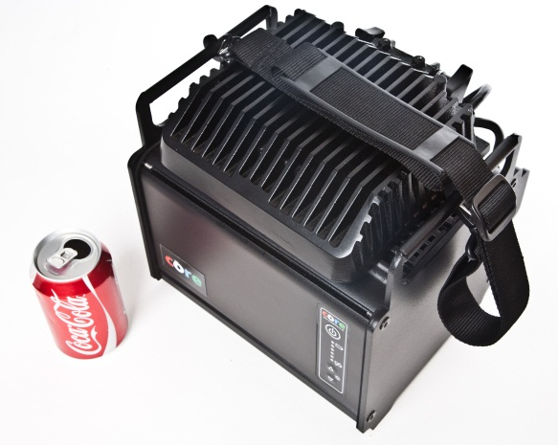
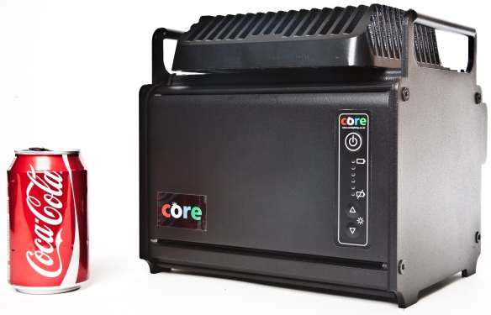
- IP65 Weatherproof for rugged outdoor use
Optional carry strap or case transforms the unit into a portable worklight
Remove head from base & mount onto 3.5m tripod, scaffolding pole, fencepost etc
Power and charging accessories from 12Vdc for vehicle charging to 110/240Vac mains supply /charging
Compact 25cm cube; head stows on top of unit for protection making this a rugged package during storage and transport

